**PF HOME TASK**

BY LINTA AFFAF

BSSE(1ST SEMESTER)

self support



QUESTION NO 1

Write a program that store 10 values in array and display maximum value on screen by using function.

**#include<iostream>**

**int findMax(int arr[], int size) {**

**int max = arr[0];**

**for (int i = 1; i < size; ++i) {**

**if (arr[i] > max) {**

**max = arr[i];**

**}**

**}**

**return max;**

**}**

**int main() {**

**const int size = 10;**

**int values[size];**

**cout << "Enter 10 values:\n";**

**for (int i = 0; i < size; ++i) {**

**cout << "Enter value " << i + 1 << ": ";**

**cin >> values[i];**

**}**

**int maximum = findMax(values, size);**

**cout << "The maximum value is: " << maximum <<endl;**

**return 0;**

**}**

}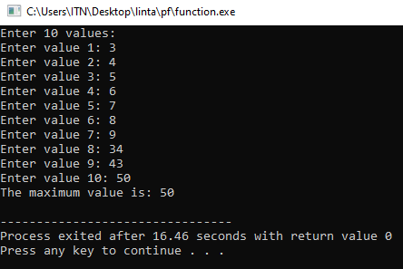

QUESTION NO 2

Write a program that take any value from user and display factorial of given number by using function.

**#include<iostream>**

**using namespace std;**

**unsigned long long calculateFactorial(int n) {**

**if (n == 0 || n == 1) {**

**return 1;**

**} else {**

**return n * calculateFactorial(n - 1);**

**}**

**}**

**int main() {**

**int number;**

**cout << "Enter a number: ";**

**cin >> number;**

**if (number < 0) {**

**cout << "Factorial is not defined for negative numbers.\n";**

**} else {**

**unsigned long long factorial = calculateFactorial(number);**

**cout << "The factorial of " << number << " is: " << factorial << std::endl;**

**}**

**return 0;**

